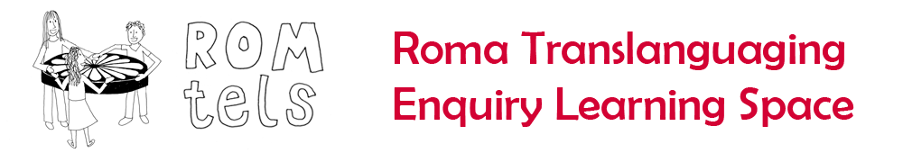
Languages for Dignity: Stereotyping Roma

Common stereotypes | Likely Prejudice | Likely discrimination: classroom level | Likely discrimination: school level | Ways of countering this discrimination
Families not interested in education | Less emotional attachment by teacher as children less likely to o come to school – less deserving | Less attention paid to children | Financial penalties? | Ask families what support they need – schools or local education

